Bahria University,

Karachi Campus



LAB EXPERIMENT NO.

**03**

LIST OF TASKS

|  |  |
| --- | --- |
| TASK NO | OBJECTIVE |
| 01 | Write a program that takes user input and then print backward counting from this input (number) till 0. |
| 02 | Write a program that prints the series of even numbers in the range of 0-10. |
| 03 | Write a program that takes an input from user and then print the table of it. |

Submitted On:

**Date: 09/10/2023**

**Task No. 01:** Write a program that takes user input and then print backward counting from this input (number) till 0.

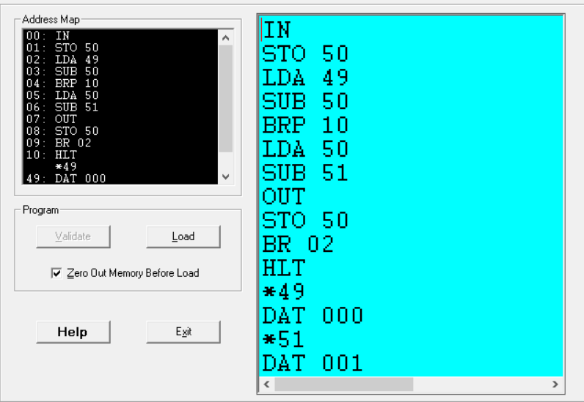**Solution:**

**Output:**

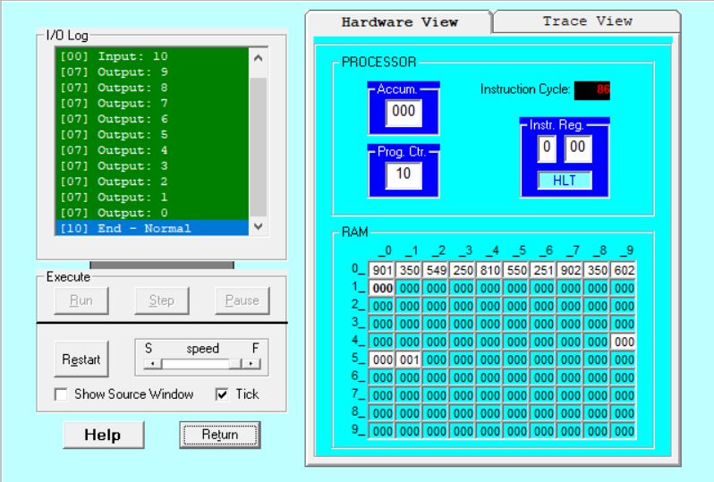Figure Hardware View

Figure Trace View

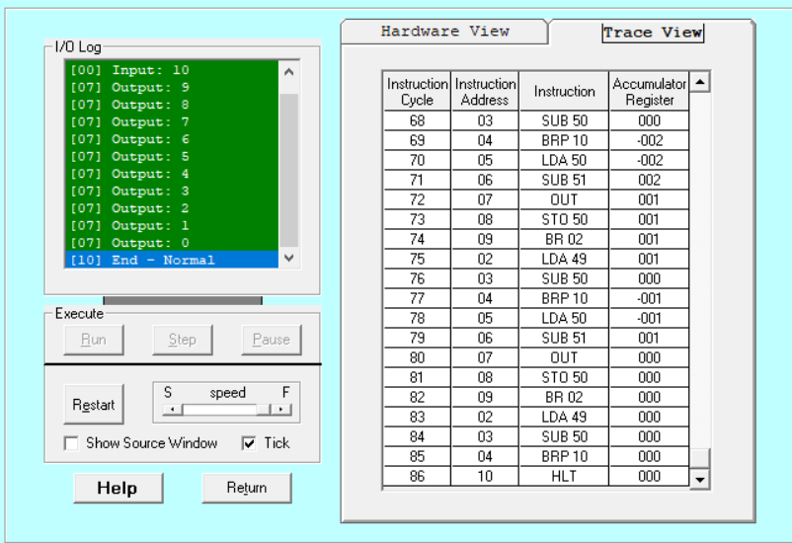

**Task No. 02:** Write a program that prints the series of even numbers in the range of 0-10.

**Solution:**

**Output:**

figure 1 Hardware View

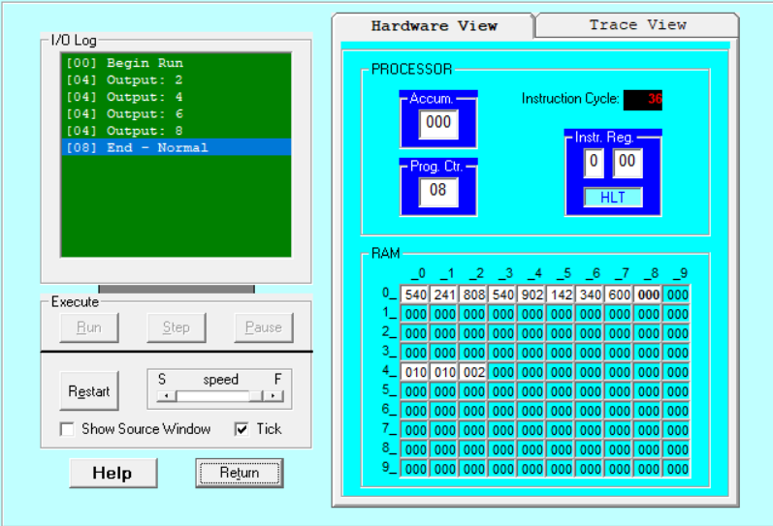

*Figure 2 Trace View*

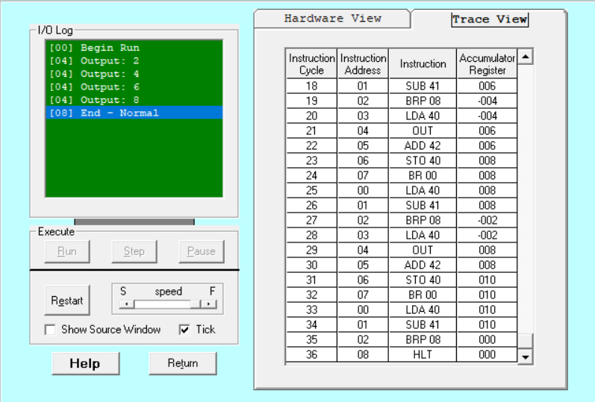

**Task No. 03:** Write a program that takes an input from user and then print the table of it.

**Solution:**

**Output:**

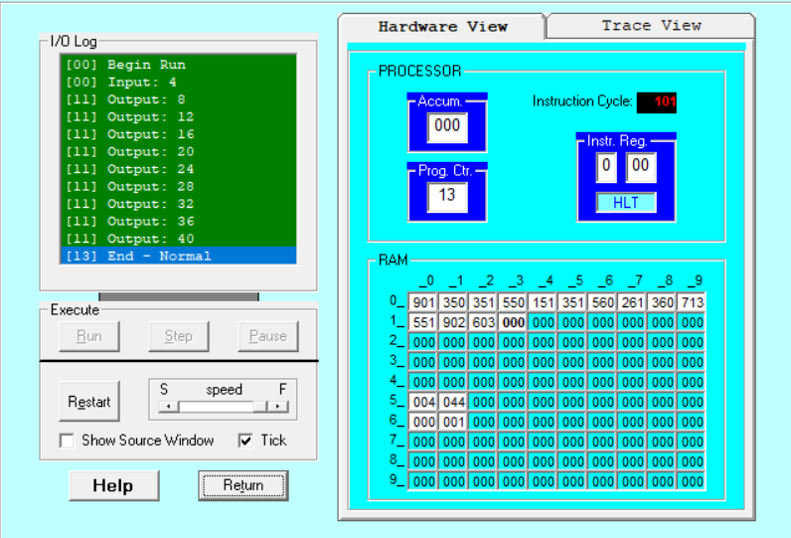Figure 1 Hardware View

*Figure 2 Trace View*

